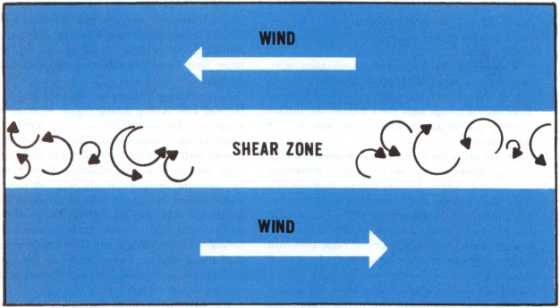

**Earth Science**

**with Laboratory**

**Charles D. McGlynn, PhD**

**ROWAN UNIVERSITY**

**Meeting Location and Schedule**:

Rob 302 **Hi-Flex**

Tue 08:00 – 10:45

Thu 08:00 – 10:45 (**Lab**)

**Office Hours**: Wed 10:45 – 11:45 and by appointment

**Required Texts**:

1. LIVING PHYSICAL GEOGRAPHY, Bruce Gervais (2015) Freeman Publishers
2. LIVING PHYSICAL GEOGRAPHY in the LABORATORY, Theodore Erski and Bruce Gervais (2015) Freeman Publishers

**Evaluation**:

Exams 30%

Laboratory exercises: 30%

Semester project: 20%

In class assignments and homework: 20%

**Semester Project** **Description:**

The semester project will involve a 10-minute presentation with your lab partner on an event or subject related to any topic from our text. To avoid duplication, all topics must be approved in advance - first come, first serve.

You will investigate your topic in depth and be able to explain the phenomenon involved, examine at least one real life example and its impacts and offer an update on what was learned as a result. You are free to offer additional examples, but at least one must be fully investigated.

**For example**: If you chose Hurricane Katrina you would be expected to explain the properties of the storm and its track, **AND** also explain why it was a seminal event that resulted in an overhaul of FEMA afterwards. What changes made to an emergency preparedness plan as a result of this storm? How have these changes worked in real life events since then?

Your presentation should include high quality graphics and photos **and provide a list of sources on the final slide**. Brief videos/clips can also be used to illustrate your project. (2 minutes is a guideline) Your final slide must include your sources and must be sent to me prior to your presentation.

A rubric for the project has been posted on Blackboard under the content tab.

**Philosophy of teaching**:

Every year, at the beginning of each semester, students wonder how working with a partner during lab will affect their grades. From personal experience, I can assure you that you will both (you and your partner) benefit from the association. Working as a team will result in better problem solving and I have no doubt you will surprise each other with creative thinking in response to stumbling blocks.

Learning physical geography is a developmental process analogous to climbing stairs. Missing class will force you to skip a step while climbing, as each step is dependent upon those that came before it. Missing earlier lectures/labs will inevitably make later ones difficult or impossible to understand.

Please ask any and all questions that you need to better understand a topic. We will all benefit from this. Chances are if you are unsure about something, your classmates also have questions and it will everyone if you ask for a clarification. If I cannot answer a question in class, I am happy to find out the answer for all of us. So please ask!

If you have a particular passion for a topic such as earthquakes or landslides, all the better, just let me know and we’ll spend a little extra time exploring it in greater depth. If not, that’s fine too, maybe you will develop an interest in a topic over the course of the semester.

Finally, I have been fortunate to have life experiences from around the country and the world and I love sharing stories of these adventures with my classes when they apply to what we are learning about and I encourage you to share your own stories and knowledge as well.



**\*\*\*Tentative Schedule*** (*dates subject to change*)**

**Week: Topics**

Jan 26 Introduction to Physical Geography and the Geographers Toolkit

Feb 2 Choose project topics, Introduction to Timezones, Atmospheric Systems, Seasons and Solar Energy. Discuss semester project.

Feb 9 Water in the Atmosphere, Atmospheric Circulation and Wind Systems

Feb 16 Weather events and the synoptic scale

Feb 23 Intro Climate and climatic zones

Mar 2 Climate and climatic zones part II, Review

Mar 9 Exam I (tentative)

Mar 16 **Projects due**

Mar 23 Projects/ Biomes

Mar 30 Soil and Water Resources, Ocean ecosystems

Apr 6 Plate Tectonics,

Apr 13 Erosion and Deposition, Weathering and Mass Movement

Apr 20 Earthquakes and Volcanoes

Apr 27 Review

May 4 Final Exam